Basic functions
For each of the following, create a new program that calls the functions with appropriate test values
- Write a function that outputs 80 stars on one line (use a loop, don’t just type 80 stars)
- Write a similar function but make it more flexible. Output n characters where n is the number of chars and the char is user defined. i.e. two parameters
- Write a function that accepts a value in degrees centigrade and returns the degrees Fahrenheit. The formula is:
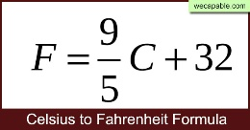
- Write a function that takes a number and the string ‘toC’ or ‘toF’ as arguments. If ‘toC’, return the value in centigrade and if ‘toF’, return the result in Fahrenheit
- Write a function that uses successive multiplication to return X^{n} . e.g. 2¹⁶, 5¹² where n is a positive integer
- Write a function to calculate n!. i.e. n factorial. 5! = 5x4x3x2x1 = 120. n must be positive
- Prime numbers are fundamental to computer security. Write a function to determine if a number is prime or not. A prime number has two and only two positive factors, i.e., it is divisible by only two numbers: itself and 1. E.g. 3. Primes are all positive integers. Primes are odd other than 2 which is divisible only by itself and 1. 1 is not prime as it does not have two factors.
To test if a number is prime, try dividing every number less than it into it. If no number will divide into it without a remainder, then it is prime. Use 20 random numbers between 0 and 999 then output whether they are prime or not. Note: you should write a function called getRand to get your random numbers.
- Write a function that calculates the probability of winning the jackpot in a lottery where you need to guess all the numbers correctly but in any order. The formula for calculating this is:
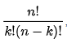
Where n is the number of balls and k is how many you need to get right. So, in the UK lotto, the balls are numbered 1 to 59, 6 balls are drawn from the 59 and you need to have guessed them all. You should determine that you have 1 in 45,057,474 chance of winning. Check out the odds with less balls or less numbers to choose from.
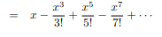
- Write a function to calculate sin(x) where x is in degrees. Use some of your previous functions to help implement sin(x)

In this infinite series, a Taylor series expansion, x is in radians. To convert degrees to radians, multiply degrees by PI/180. The more terms used, the more accurate the result.
To test your results, calculate the sine of the angle using the Math.sin function and output both side by side. Note, Math.sin requires the angle to be in radians. Plot all values from 0 to 360 degrees at 10 degree intervals
- Create a function getRand(). The function should have three parameters: lower, upper and type. Lower is the lowest random to return (it can be negative), upper is the largest number to be returned and type can be: ‘odd’, ‘even’ or ‘any’. If ‘odd’, only return an odd number, if ‘even’, only return an even number and if ‘any’, return and odd or even number in the specified range.
Example call line:
let rand = getRand(0, 30, 'odd’)
let rand = getRand(-10, 30, 'even')
let rand = getRand(1, 100, 'any')

Write a program to call your function with various arguments to test it

- Create a structured solution, using functions where appropriate, to solve the following problem. Provide suitable test values to demonstrate your program functions correctly:
From the government HMRC website https://www.gov.uk/income-tax-rates
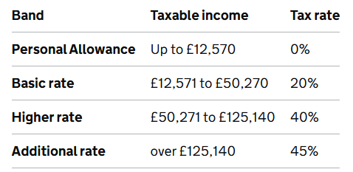
The amount of tax you pay is calculated from the table on your whole salary (gross salary)

Requirements
You have an array of employee annual salaries and need to compute the amount of tax each needs to pay that that year.
Output the gross salary and annual tax payable for each salary in the array.
The salary values should be chosen to clearly test each path through your code.
Your code should be modular so use functions appropriately.
Check your results using the online tool: https://www.tax.service.gov.uk/guidance/estimate-your-self-assessment-tax-bill

Note: If you earn over £100,000 then the amount of tax free allowance (personal allowance) reduces at a rate of £1 in every £2 over the £100,000 until it’s all gone – i.e. after £125,000 you get no personal allowance. To keep this simple, we will only work with salaries up to £100,000 unless you want to take on the extra challenge.
Answers may be a few tens of pennies out depending on how you round figures compared to HMRC so don’t worry about that

